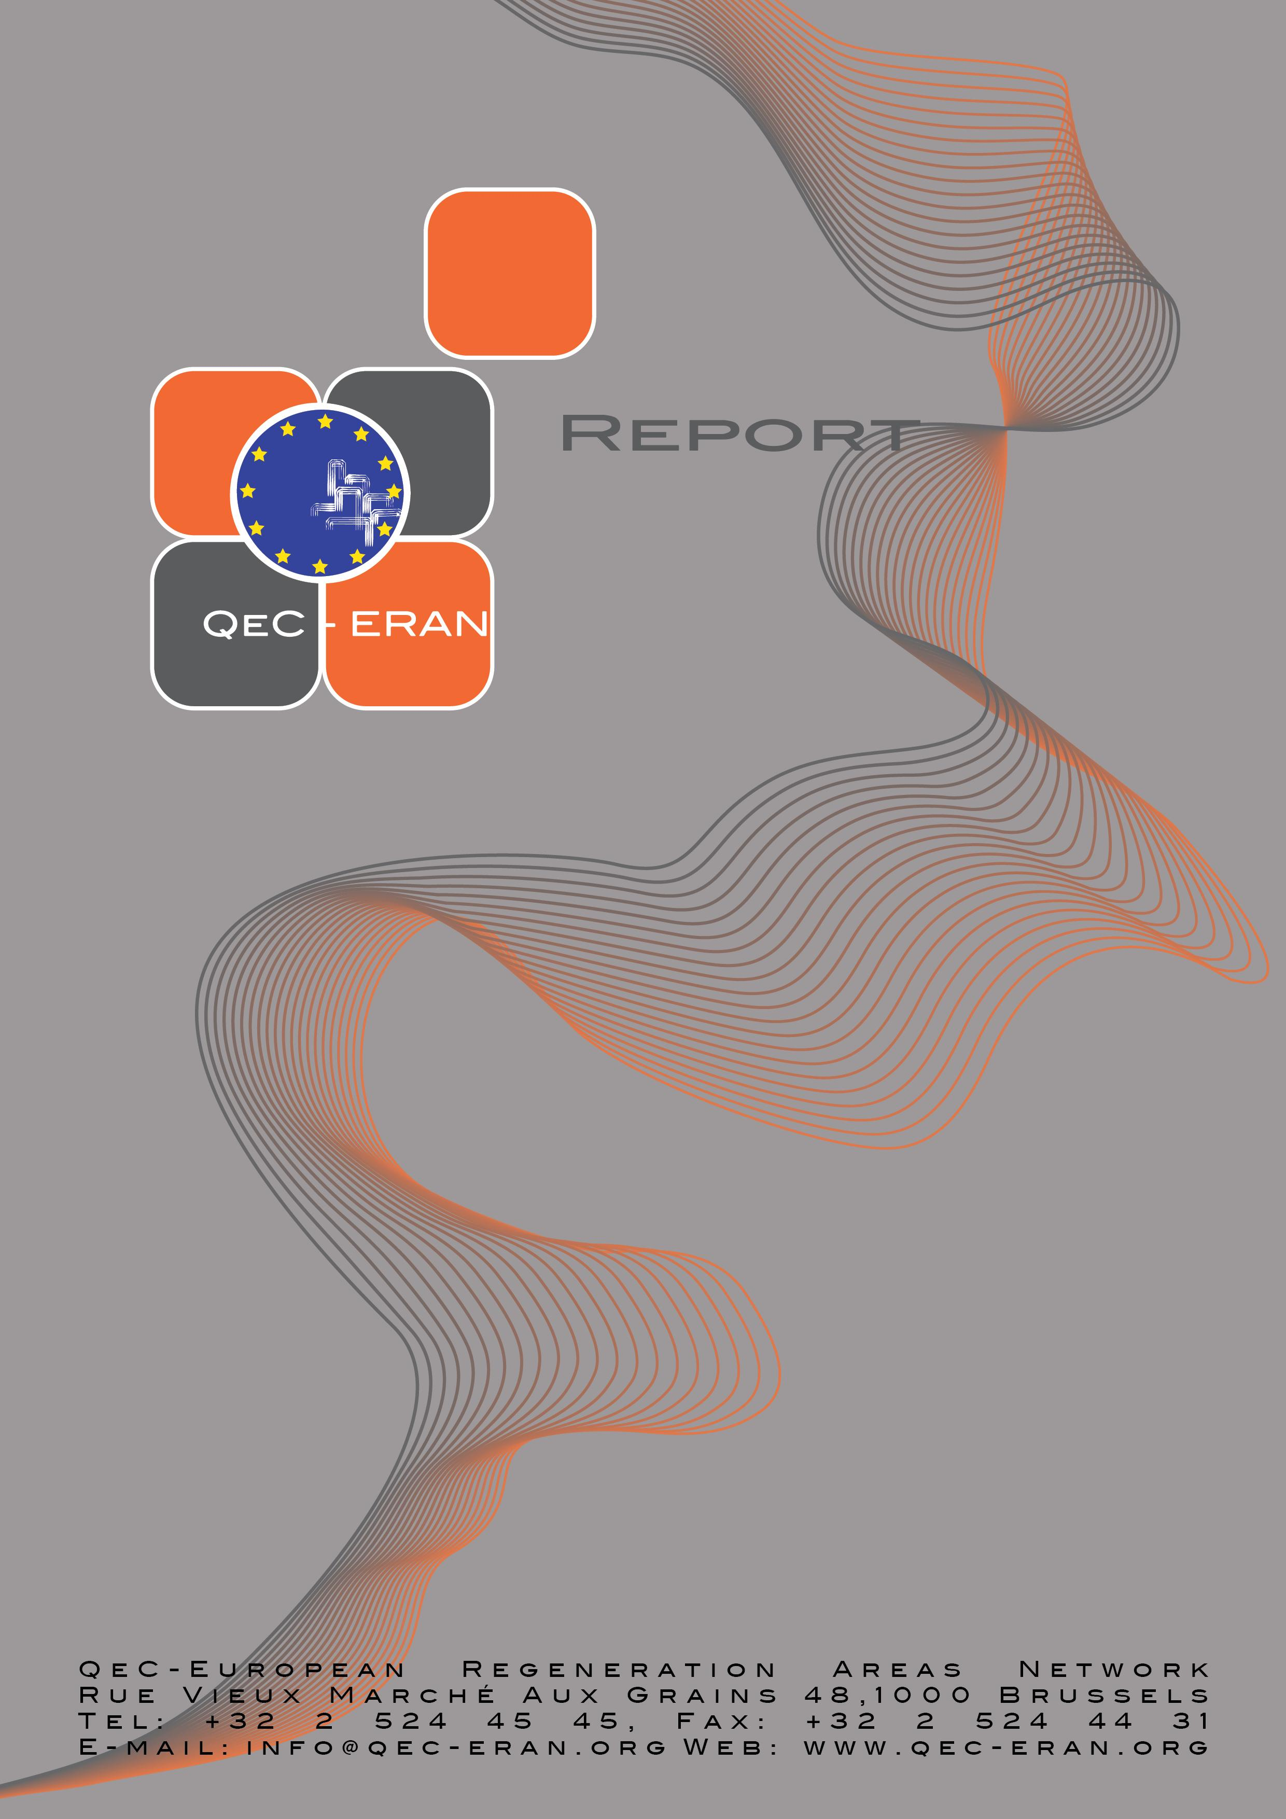

Sharing domestic responsibilities:
The role of men

Table of Contents:

Introduction 2
1. The European context: macro and micro conditions 3
1.1 Macro conditions are important 4
1.2 The micro level: degendering tasks 5
2 Influence of the conditions: study of exceptional practices 6
2.1 Innovations in European countries 7
3. Changes and challenges 8
3.1 Factors creating pressure for change 8
3.2 Barriers for change and reaching gender equality objectives 8
3.3 Means for change, actions and practical solutions to overcome barriers 9
3.4 Societal changes and dilemmas in the framework of gender equality 10
4. Some Recommendations 11
5. Conclusions: Men and gender equality in Europe - measures or pilot actions. 12
Bibliography 14

Introduction

The last few decades the number of women entering the labour market increased considerably all over Europe, but men did not take up caring tasks in a proportionate way. In all European countries men take the biggest part in paid work, while women do most of the caring for children and the household. In most European countries women do twice as much caring for children than men. In all European countries women perform more care and household tasks than men, even if they have a full time paid job.
To illustrate this, we give some figures concerning participation in paid work and concerning hours per week spent on household tasks by men and women.

Table 1: Labour market participation rates and weekly time for household tasks of men and women
country | Labour market participation rate in % of people between 15-65 years of age |  |  |  |  | Household tasks hours per week
country | women |  |  | men |  | women | men
country | 1995 | 2005 | Of which Full time (2000) | 1995 | 2005 | 2003 | 2003
France | 52 | 58 | 65 | 67 | 69 | 18.2 | 10.4
Hungary | 45 | 51 | . | 60 | 63 | 27.7 | 11.0
Italy | 35 | 45 | 67 | 67 | 70 | 25.3 | 18.0
Netherlands | 54 | 66 | 28 | 75 | 80 | 23.8 | 11.6
Slovakia | . | 51 | . | . | 65 | . | .
Spain | 32 | 51 | 71 | 63 | 75 | 23.8 | 13.4
UK | 62 | 66 | 48 | 75 | 78 | 25.9 | 13.7

As can be seen in this table, there is an important variation in male and female employment rates through Europe. The same goes for the variation in part time work of women. Therefore, it is interesting to look at difference in employment rates between men and women, in full time equivalents. The following graph shows this employment gap for 30 European countries.

Graph 1: Employment gap in full-time equivalents 2003

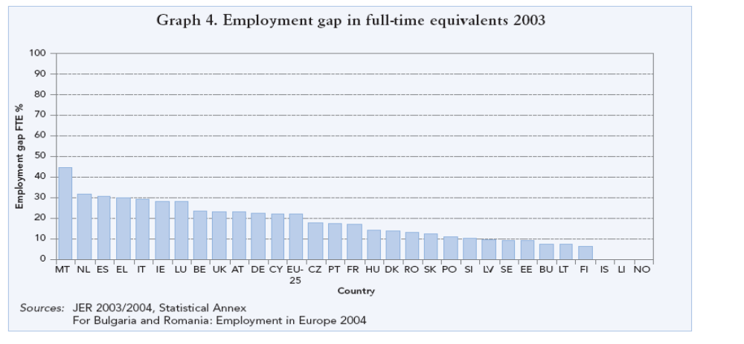

The actual division of tasks between the sexes is a problem as far as it hampers people’s freedom of choice. Women more in particular are confronted with the limits of their possibilities and the restrictions in their freedom of choice. If women have to take up more paid work, men will have to be stimulated to take up more care tasks… and do less paid work.

1. The European context: macro and micro conditions

For different reasons European governments and the European Union would like to see an increase in the labour market participation of women.

On a macro level following reasons play explicitly or implicitly a role in this:
- Enforce the competitive power of (EU) countries;
- Limit the claims for income substitution;
- Enlarge the (financial) basis for taxes and social security;
- Keeping salary claims within certain limits.

There are also reasons on the micro level to put the division of paid work and care tasks between men and women on the agenda. Realising the European countries’ and the EU objective of increasing the labour market participation of women, is only realistic and fair, if this goes along with an increase in the share that men take in the care for children and the household. If men will not change, women will not increase their labour market participation, or they will have to accept much more work load for realising the increase in labour market participation.
Moreover women have also less freedom of choice as to the household tasks. Somebody has to perform the less agreeable tasks. If men do not take responsibility, women will have to perform these tasks. In the end it is a matter of fair and just division, once men gave a comparable contribution to the care for children and the household.
An important element of the context for these arguments lays in the demographic challenge. To ensure our future, we will need to have more children AND as a result more people (men and women) will have to take an increased role in both paid work and unpaid care tasks.

There is a clear need therefore for initiatives in three policy directions at the same time:
- Children and family friendly equal opportunity policies
- Policies for alleviating the burden on women
- Increase incentives for men to take up more care tasks

Some of the policies developed during the last decades do not support a combination of these three directions. The development of 7 days, 24 hours child care facilities e.g. does alleviate the burden for women, but is not necessarily child friendly; neither does it stimulate men taking up more care tasks. Sometimes policy options in different sectors could even be conflicting. One example is the option to increase labour market participation of women and the option for counting more on voluntary caring. Policies to be developed should be proofed for their complementary quality as to the three policy directions.

The existing task division between men and women is influenced by three types of conditions respectively, the macro, meso and micro levels. These conditions influence both the degree of male involvement in care tasks (the quantity), and the kind of tasks that men perform in household and family (the quality).

1.1 Macro conditions are important

The macro conditions relate to time (flexible working patterns and leave schemes), money (tax systems) and provisions (child care). For a fairer division of all paid work and care tasks, good national arrangements are necessary as to child care, parental leave, life cycle arrangements, the right to work part time etc. These arrangements are of great importance to make the first steps to a more just division of tasks. Men will perform more tasks in the household. Women will have a more realistic possibility to take up paid work.

Some of the macro conditions to improve are in the fields of:
- Flexible working patterns
- (Paid) leave schemes on an individual basis
- Tax advantages for dual-income families sharing care responsibilities
- Adapted opening hours
- Accessible and affordable childcare facilities

But more has to be done
Because even if macro conditions are favourable for enabling men to take up care tasks, men have a clear preference for the type of tasks to fulfil (such as shopping and cooking) and for leaving other household tasks (such as cleaning and laundry) for their partner. Also men have a clear preference, for the care of the children, above household tasks. There seems to be, as far as men are concerned, a clear hierarchy in the tasks to perform.

Research has shown that the difference between men and women in taking up care tasks is culturally determined. This means that this difference is open for change, even if change is not easy to realise. It becomes important not only to influence the amount of time that men and women invest in household and care, but also to change the division of the types of tasks. This could be done on a meso level through a qualitative approach of the conditions under which men and women divide paid work and care tasks.

On micro level efforts should concentrate on the disassociation of care tasks and gender stereotypes. This includes creating mechanisms to help women and men sharing care tasks, training men to take care of others and of themselves, campaigning for taking up existing facilities, etceteras. Tasks can become “beyond” gender.

1.2 The micro level: de-gendering tasks

We need more knowledge about the mechanisms behind the unfair division of household tasks. Tasks have a gender connotation. How to get them beyond gender? In a study by Verwey-Jonker Institute this was done through an analysis of three tasks, i.e. shopping, doing the laundry and visiting the baby clinic. The description of each of these tasks shows that it is possible for a specific household task (e.g. shopping) to lose its female connotation. This will then mean that there will be no barrier for men to fulfil this task. A stimulating factor can be that a task is part of a “chain”. When men do the cooking, they will consider it fully normal to also do the shopping. Men who dress their children in the morning will get concerned with the availability of clean clothes. The study also shows that visibility of a task and more tolerance (of women) for mistakes made (by men) are important factors for men to take up household tasks. In the Netherlands one could observe that visiting the baby clinic is an activity in full transition towards changing its gender connotation, while doing the laundry, remains to a great deal a women’s business.

Important interlocked mechanisms for (or against) “de-gendering” are:
- A “chain” approach: if one task from a chain becomes gender neutral, other tasks from the same chain could follow that direction easier;
- Visibility: men will more easily take up visible, public tasks such as shopping and visiting the baby clinic. If more men perform these tasks this will of course stimulate other men. But it could also influence taking up other tasks as far as they are part of a chain;
- Tolerance: another important element is the fact that men and women perform the same tasks in a different way. If men take up tasks that traditionally belong to the territory of women, tolerance for difference and for making mistakes will play an important role;
- Control and execution: household tasks can be transferred gradually from women to men. This could be first in terms of execution, while women keep control. Step by step men can take up also control over certain tasks. Shopping is a nice example for this. We could observe that older, rather than younger men use shopping lists made by their partner. Younger men are more independent in shopping. We observed similar mechanisms in doing the laundry.
- Home alone: men take up household and child care tasks more easily if they are alone at home with the children. This point refers to meso conditions, namely the organisation of paid work in relation to the care for household and family.

2 Influence of the conditions: study of exceptional practices

In the same study of Verwey-Jonker institute, researchers also wanted to investigate to what extent the conditions influence both opinions about task division and the factual behaviour. Therefore, they questioned household types that could be seen as having an “exceptional” practice in terms of the conditions for combining paid work and care tasks. In the “standard practice” a household is composed of a man, a women and a child or children; the man has paid work outside the home at regular hours (between 8:00 and 18:00 hours) and the woman (with or without a paid job) is (mostly) responsible for household and care tasks. A practice is considered as “exceptional” if the man works at non-regular hours, or has an unusual work pattern, or is part of a special type of household. The study included 30 exceptional households, consisting of households with shift working men, with men doing tele-work and households with homosexual fathers.

The most important conclusion of studying the exceptional practices was that opinions and preferences of men in relation to the task division between men and women are strongly related to the possibilities of men to combine caring with paid work. In households where a more equal task division already exists, competences of men, their preferences and the traditions of their education, seem hardly important. The opinions of men are flexible if they – due to changing conditions – have to perform certain tasks. Even (supposedly poor) competencies no longer appear to play a role. Being at home alone with the children appears to be an important stimulus for men to really perform caring tasks. A similar conclusion was drawn from a Norwegian study into men on parental leave.

2.1 Innovations in European countries

In most European countries it appears that a more fair division of paid work and care tasks between men and women is an urgent issue. But situations and traditions are pretty different. So are the issues at stake, the challenges to overcome and the appropriate answers. As examples the study gives a glimpse of the issues in three countries that stand for three different societal and policy traditions in respect to conciliation of work and family life: Sweden, France and Spain. Looking into good practices (mostly at local level) for stimulating men to take up child care and household tasks this gives the following images.

- Sweden has a longstanding tradition of state intervention in relation to the role of fathers. In this field, local authorities developed several initiatives influencing the amount of child care tasks that men take up within the household. Most of these initiatives are indeed limited to the care for the children. Putting the division of household tasks between men and women on the (family) agenda appears also in Sweden a difficult issue.

In this respect it is remarkable that the latter is explicitly the case in Spain. On local level as well as in national campaigns, the Spanish public authorities stimulate men to take up more care tasks. Both care for the children and for the household are included in these campaigns. Apparently Spain is catching up for a more traditionalist past. At the same time, social scientists in Spain are warning for the distance between the political and the social moral in these issues.

- In France it seems to be difficult putting the subject of men and care on the policy agenda. The cause lays in the fear for public interference with “private” issues. Slowly the societal climate is changing also in France, as to make it possible to intervene in this field, because the limits of what could be achieved with improvements of macro- and meso conditions are becoming more and more clear. France has a strong tradition on these levels. But people do ask themselves whether the wellbeing of children (and their parents) is served with a stay of more than ten hours a day outside the family. Also, more and more (local) policy makers realise that the principle of non intervention in the “private” sphere leads to a systematic overburden on women, which has great influence also on the possibilities for women to participating in public life.

3. Changes and challenges

3.1 Factors creating pressure for change
The factors creating pressure for change are:
- macro-economic: the need for women’s participation on the labour market;
- micro-economic: the need or wish of women for economic independence;
- political: the requirements of equal opportunities’ policies;
- cultural: the growing awareness of women’s rights; women’s high level of education.

3.2 Barriers for change and reaching gender equality objectives
Barriers for change have to be sought in the same existential fields:

In European policy making, there is a kind of “average” symbolism, throughout the benchmarking practices, i.e. if a country performs within the European average; policy makers are satisfied, even if this is no progress at all for the country at stake. Examples are the decrease in female employment, accompanied by decrease in infrastructure in some new member states. The adagio of freedom of choice can be easily used for accepting inequality. Furthermore, citizens tend to refuse interventionist policies, due to longstanding experience of authoritarian government.

In economy, the gender based inequalities and discriminations in work organisations (unequal pay, glass sealing…) reinforce the traditional unfair sharing of domestic responsibilities. If the father’s salary is higher than that of the mother, it is not a rational choice for the father to take parental leave. Household work is economically not valued. But what would happen if it would be paid? Moreover, if a couple has a high enough income, they prefer to pay for domestic services instead of sharing these tasks themselves. So, domestic work could also not be very highly valued in a cultural sense.

Culturally, persisting stereotypes and cultural norms are strong barriers for change. Women are still primarily seen as caretakers and responsible for the household. Caretaking men are seen as disempowered (not really masculine). There is strong pressure from the community and society as a whole on men to play traditional roles.

The media generally reinforce conservative images. Either they show men and women in traditional roles, or they show a non realistic idyllic image of the “new man”.

The “new young women” on their side are Cosmo-girls: they make their known choices, live for their job, and enjoy life. But once they enter in a partnership relation there is a great risk that they lose their independence and shift to traditional roles.

3.3 Means for change, actions and practical solutions to overcome barriers
In spite of these strong barriers, participants of the workshop do believe in possibilities for change. In fact, the ways to change could be seen as the other side of the “barriers” coin.

Participants have high expectations from education. Basic change in gender roles has to begin with boys’ (and girls’) education in families and schools. The encouragement for boys to taking up caring roles (and jobs) is a crucial leverage for change.

Equal pay, paternity leave schemes and flexible working time are necessary conditions for change but even when these circumstances are given, they will not automatically result in changes and fairer sharing of domestic responsibilities. But, step by step, changing conditions will give men the possibility to develop caring competencies.

Cultural change is taking place all over Europe, but at different speeds. Policy makers play an important role in this change. Due to the Open Method of Co-ordination and the gender mainstreaming objectives of the European Union, local and national authorities create and promote new opportunities for better conciliation of work and family life for both men and women. Men’s and women’s movements for gender equality find often strong allies among policy makers. Public authorities, more in particular at local or regional level, can influence both the citizens and private business by giving a good example as employers and service deliverers. Adapted time and space policies (opening hours, mobility plans…) can play an important role in changing the conditions for reconciliation. Moreover local (regional) government can negotiate with social partners (trade unions and employers) and individual companies about local plans for conciliation (promoting paternity leave, flexibility in the labour market).

The media should also play a role in changing gender stereotypes. They could support the debate in an interactive way.

Finally, the participants came up with a methodological idea: if you want success, you should define a concrete and realistic objective about the issue at the (policy) level where you can have influence. In looking for alliances, one will have to recognise the possible different arguments for change. It is very well possible to make productive compromises between individual, family and business interests. But one should know very well what the different change agents want, and what the different interest groups stand for.

3.4 Societal changes and dilemmas in the framework of gender equality
Thinking of gender equality, a number of important societal changes have to be seriously taken into account.

The demographic challenge asks for a children friendly environment. This means that the exclusive pressure on men and women to fully participate in paid work has its limits. Special attention should be given to the millions of European households in risk of poverty. Leave schemes, part time work and forms of flexi-curity, are not evidently helping these households to balance work and family life.

Another issue is the growing diversity, both in household types (divorces, recomposed families, singles, and care for the elderly…) and ethnicity. Specific approaches for specific population groups will have to be developed.

4. Some Recommendations
The recommendations and conclusions in these last two sections build on the outcomes of the Genderwise project. It is an Urbact project led by Qec-Eran to support the development of integrated Local and Regional Action Plans for Gender Equality, with a specific focus on developing and promoting the role of men as change agents in the reconciliation of work and family life.
Genderwise has been run from January 2006 to February 2007 and involved 12 partners from 8 European countries. Among the outcomes, it produced an online policy and practice "market place" (Agora Praxis) presenting all the partners presentations and project case studies in order to capitalise on existing practice at local, national and European levels.
All the material and documents related to this project can be found at http://www.qec-eran.org/projects/Genderwise_index.htm

It is certainly necessary to continue promoting the existing and planned measures at different levels for conciliation of work and family life. The effects of these measures on a more fair distribution of care tasks should be carefully monitored. Some measures seem to be crucial for stimulating men to take a fair share in caring.

On a macro level it is important to develop individual (paid) leave arrangements (see e.g. Belgium) and specific paternity leave arrangements (home alone). But also more general measures such as the right for temporary part time work, as it was introduced in the Netherlands, could have a real influence on a more just division of paid work and care work.

On a meso level, one should not forget the importance of good provisions, but also a stimulating culture at the level of work organisations.

On a micro level one should mention the chain approach and the promotion of tolerance. But also mobilising professionals can be very helpful. This could be done in two ways. One way is to stimulate that more men have access to certain professions (health care, baby clinics, child care, home care, household services). The other, is to give attention in the training of these professionals to the role of men in the care for household and family. Young parents are absolutely sensitive for professionals systematically asking for the active presence of the father.

The appeal on men to fully play their role as fathers is an important intermediate step towards a more fair distribution of all tasks between men and women.

But men will not only have to play a more important role in the care for children. They will have to get more involved in all household tasks. To call upon men as fathers because of the importance of that role for their personal development and that of other family members, bears the risk that men will continue to leave the less pleasant household tasks to their partner: “this is not why I took up parental leave!” In the long run one should publicly reflect about masculinity and femininity in relation to the division of tasks. Diversity and freedom of choice are keys in such reflections. The question is no longer IF men will have to take up certain tasks. The question will be about a desirable division of tasks between partners, man and women, within households. Each partner could take part in all tasks: this would be a fair starting point for discussions at the kitchen table.

5. Conclusions: Men and gender equality in Europe - measures or pilot actions.

Gender mainstreaming is an important policy principle of the European Union. Promoting measures to ensure equal opportunities for men and women on the labour market and in work organisations are important objectives of the European Commission. At the same time, the subsidiary principle leads the way to achieve these objectives to the member countries. With the Open Method of Co-ordination, the European Commission stimulates countries to learn from each other, to benchmark their achievements and in this way hopes for convergence.
It is clear that this convergence is growing in the field of measures to facilitate conciliation of work and family / private life. Even if differences between countries remain important regarding parental leave schemes, tax provisions for two earner families or single parents, subsidies for (child) care services, countries are clearly under pressure to adapt their systems and measures to meet the better performing European countries, in order to achieve the Lisbon objectives.

Gender equality was for a long time considered by most actors as a women’s issue. Women indeed had to fight for their rights and little was to be expected from men, because they had to give up their privileges.

At local level however, and in scientific circles, the role of men and fathers came to the fore many years ago. It became clear that it is in the interest of men themselves, in that of their families and of society as a whole that men invest more in private life than they happen to do. New feminist insights, pedagogical concerns and concerns of single fathers were important leverages for the changing views on men and fathers.

In that light, a lot of new initiatives (father centres, father courses, and father’s clubs) to support men and fathers in taking up new roles in private life were developed in several countries. These initiatives got public support, first in Nordic countries, but also more and more in other countries.

At the same time, one has to recognise that existing possibilities for the conciliation of work and private / family life are far from being fully used. The non take up of possibilities is important in all European countries, regardless of the importance of these measures. It is clear that more has to be done at meso and micro levels to facilitate and motivate men in changing their relationship to work and family life.

European programmes, such as Equal and other programmes subsidising initiatives for equal opportunities and gender equality more in particular gave extra possibilities for developing innovative approaches to the issue of men and gender equality. For the first time during the Finnish presidency in 2006, the issue of Men and Gender Equality was put high on the European political agenda, through an expert conference in Helsinki.

During 2006 and 2007, a number of transnational projects have been financed by the European Commission to gather knowledge and experience from local and regional initiatives on men and gender equality. Initiators and participants of these projects range from local and regional authorities, family organisations and federations, community development agencies, to consulting and research agencies and academics. The activities range from policy development plans on local or regional levels, campaigns to convince companies or individual citizens to training activities for young fathers. The products also are very different: research findings and reports, a guidebook for local authorities, a European Charter to be signed as a personal commitment by male key-persons, catalogues and descriptions of good practices. It would be worthwhile if the European Commission made an extra effort to produce – and disseminate largely - a good overview of all this new knowledge and experience

Bibliography

Some relevant literature

Cleveland, G. & Krashinsky, M. (2004), Financing ECEC services in OECD countries, Paris: OECD. Downloadable at http://www.oecd.org/dataoecd/55/59/28123665.pdf.

Duyvendak, J.W. & M.M.J. Stavenuiter eds. (2004) Working Fathers, Caring Men. Reconciliation of Working Life and Family Life. The Hague/Utrecht: Ministry of Social Affairs and Employment / Verwey-Jonker Institute.

European Commission (2006). A roadmap for equality between women and men 2006-2010. COM (2006) 92 final. Brussels: European Commission.

Fagan, C. & Hebson, G. (2004), ‘Making work pay’ debates from a gender perspective: A comparative review of some recent policy reforms in thirty European countries, Manchester: European Work and Employment Research Centre. Downloadable at: http://europa.eu.int/comm/employment_social/gender_equality/gender_mainstreaming/gender/exp_group_en.html

Plantenga, J. & C. Remery (eds.) (2005). Reconciliation of work and private life: A comparative review of thirty European countries. Luxembourg: European Commission.

Pringle, K., J. Hearn et al. (2006). Men and Masculinities in Europe. London: Whiting & Birch.

Sleebos, J.E. (2003), Low fertility rates in OECD countries: facts and policy responses, Paris: OECD.

Varanka, J., A. Närhinen & R. Siukola (eds.) (2006). Men and Gender Equality. Towards Progressive Policies. Report of an EU presidency expert conference. Helsinki: Ministry of Social Affairs and Health.

Web sites

Gender Equality web site of the European Commission:
http://ec.europa.eu/employment_social/gender_equality/index_en.html

Equality between women and men web site of the Council of Europe:
http://www.coe.int/T/e/human_rights/equality/

Gender Statistics web site of the UNECE (United Nations Economic Commission for Europe):
http://www.unece.org/stats/gender/welcome1.htm

European Women’s Lobby web site:
http://www.womenlobby.org/site/hp.asp

Gender Equality Links of the OECD:
http://www.oecd.org/dataoecd/47/35/1896261.htm

Pariteia project web site:
http://www.pariteia.org

COFACE project Men in Families:
http://www.coface-eu.org/public/english/html/politique/hommes-familles.html

UK-Croatia Gender Equality Project:
http://www.liv.ac.uk/law/ukcroatia/index.htm

Project All Together - it’s up to you: Equality starts at home:
http://www.all-together.org/index.php?act=3

Equal Pay project of EFILWIC (European Foundation for the Improvement of Living and Working Conditions:
http://eurofound.europa.eu/eiro/2002/12/Feature/NO0212103F.html

European Fatherhood project – Men and Parenting:
http://fatherhood.social.dk/

Focus – Fostering Caring Masculinities project:
http://www.caringmasculinities.org/

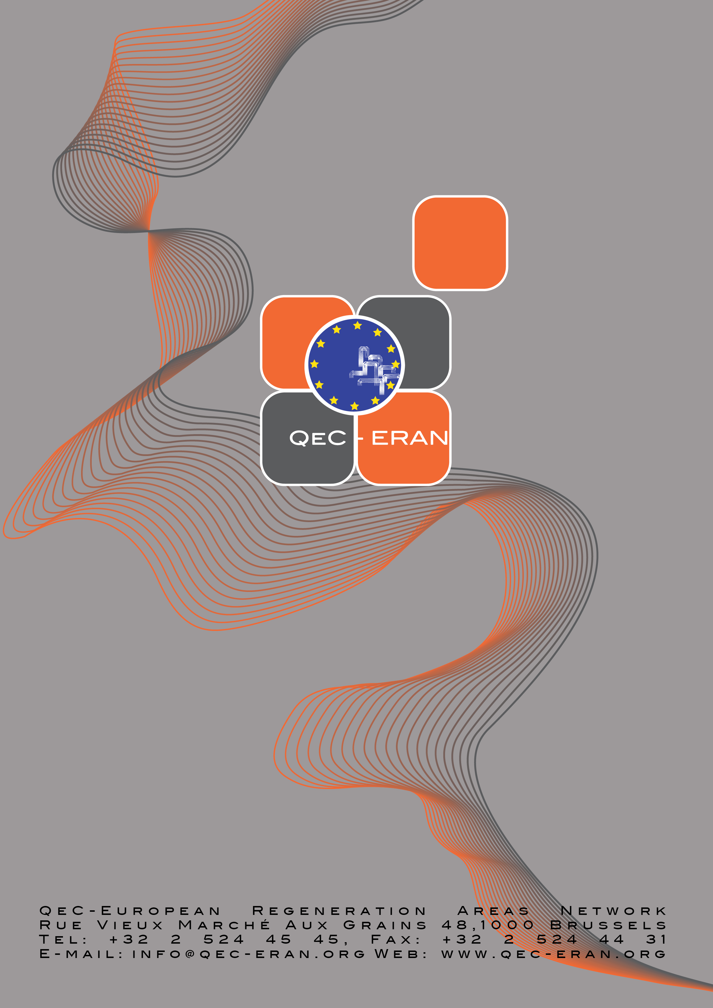

J.W. Duyvendak & M. Stavenuiter (eds.) (2004). Working Fathers, Caring Men. Ministry of Employment and Social Affairs, Verwey-Jonker Institute. The Hague, Utrecht.

